- store
- services
- vision
- unit planner
- sardine blog
- contact

homecommitted sardine blog10 fun tools to easily make your own…

10 Fun Tools To Easily Make Your Own Infographics
Posted by Ryan Schaaf on February 12, 2013
“Infographics provide a wonderful visual representation of information and data. The combination of written information and graphics provides a compelling method for students to publish research in a visual way. In this article for Edudemic, Katie Lepi graces us with 10 wonderful examples and their direct links—they're sure to help students build exciting and appealing infographics all their own.”

via Edudemic
People love to learn by examining visual representations of data. That’s been proven time and time again by the popularity of both infographics and Pinterest. So what if you could make your own infographics? What would you make it of? It’s actually easier than you think… even if you have zero design skills whatsoever.
Below are my two favorite infographic-making web 2.0 tools that I highly recommend. They both have pros and cons but in general are great for any beginner or novice designer. If Photoshop is a 4-letter word to you, then these sites are your friend. If you’re a tech-savvy designer and illustrator, it can’t hurt to check out some of the work on these two sites for inspiration.
Click the name of each tool to learn more!

Visual.ly
One of the more popular ways to discover infographics, Visual.ly actually just launched a design overhaul of their website. It’s much more social and easier to share infographics. But since most of us don’t make infographics (yet), let’s focus on the killer tool that Visual.ly does offer: infographic creation.

Dipity
Want to get a beautifully simply visualization of data over time? It’s easy to use Dipity to create certain types of web content in a highly visual format. Consider using Dipity as a tool to map out the history of just about anything by creating multimedia timelines.
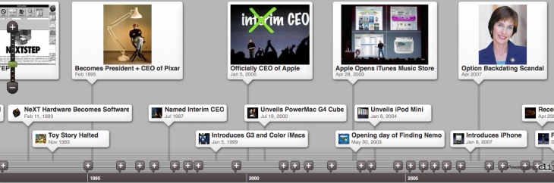

Easel.ly
I absolutely love Easel.ly. It was one of the first tools I found that helped me create a few infographics for the Edudemic Magazine. It’s also grown quite substantially over the past few months, yet is still in beta. Therefore, be on the lookout for some more improvements to the web-based software. For now though, easel.ly lets you easily (get it?) create various charts by just clicking and moving the mouse. No data skills required.
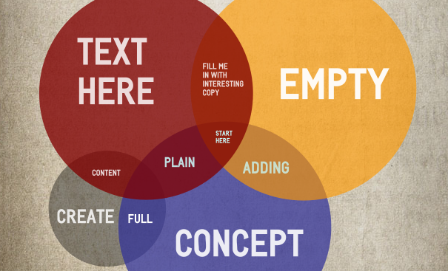

Venngage
Venngage (likely named for Venn diagrams) is a double threat. It lets you easily create infographics and other data visualizations but, more importantly, it lets you track the analytics of who is viewing your infographic. Could be great for a classroom of students who want to see who can make the most popular infographic!
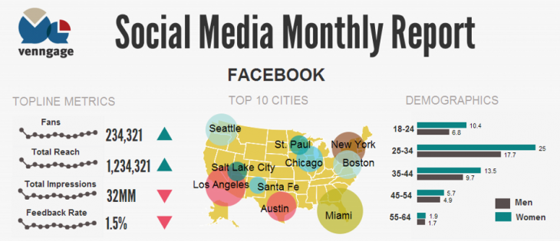

Infogr.am
One of the most simple tools, Infogr.am lets you actually import data right into the site and then translate it all into useful visualizations. What could be better than that? I could see this being useful for making large posters showing off attendance, performance on certain metrics, and other classroom-based data streams.
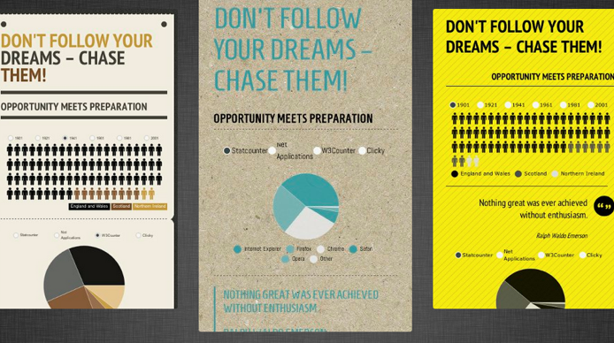

Tableau Public
Made for Windows, Tableau Public lets you (like Infogr.am) bring your actual data into the world of visualzation. I like their maps feature but can see the value of using the tool on a regular basis thanks to the ‘live dashboard’ that lets you monitor all aspects of your design. Great for teachers without a lot of time or for a project-based learning environment that wants to track metrics. Best of all, you can make the infographics into interactive web-based visualizations with ease.
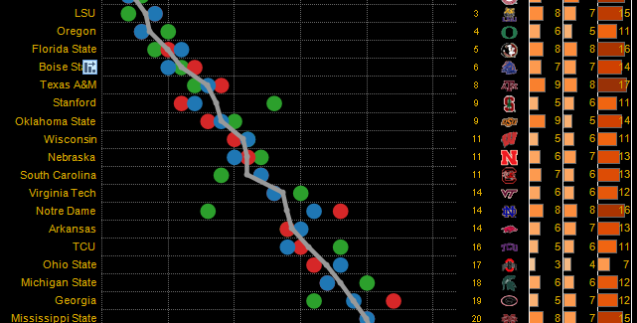

Photo Stats
This one’s an iPhone app that’s worth trying out. It simply analyzes the photos on your iPhone and then turns them into nifty infographics. Pretty simple and could be fun for trying out every once in awhile. Costs $0.99 but would be fun to use for a 1:1 or PBL classroom that takes photos on a regular basis. Good for tracking usage of the iPhone’s camera etc.
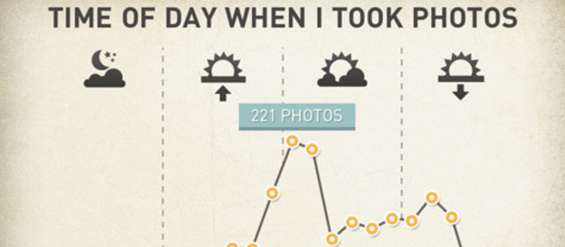

What About Me?
Want to show off your social media skills? Intel whipped up a nifty tool that I haven’t seen mentioned in many education blogs so I figured it’d be helpful to share. The tool is called What About Me? and it lets you create an infographic based on your social media accounts. Visual.ly also does this but this tool ties in a few more social networks. YouTube, for example. Great for a classroom of avid social media users!
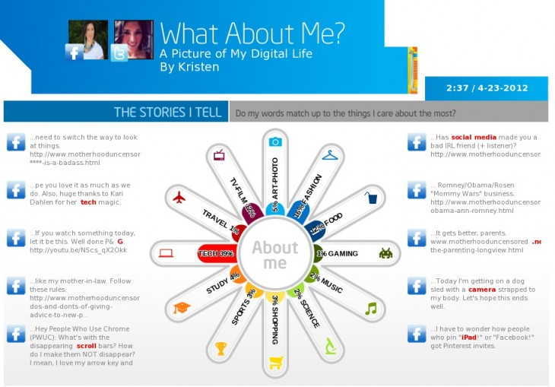

Gliffy
Want to spice up your next faculty or staff meeting? Gliffy (love the name, btw) lets you whip up flowcharts, floor plans, and pretty technical renderings with ease. It reminds me of Prezi but generates static images. Useful for presentations by both teachers and students.
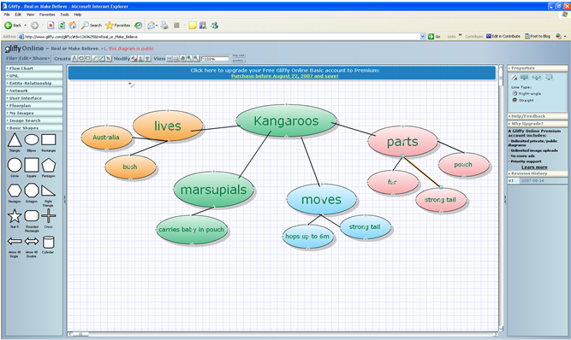

Piktochart
Saving the best (imho) for last! A favorite of the Edudemic audience, Piktochart is a great way to visualize just about anything. You can drag and drop your way to visual success by using Piktochart’s themes and other ready-made tools. Piktochart lets anyone (even those without design skills) become a graphic designer in no time!
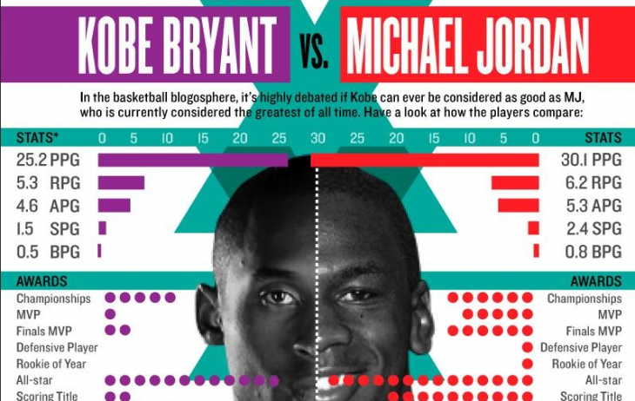

Share this:
- Twitter71
- Facebook
- LinkedIn11
- Pinterest
- Email

Tags: infographics, learning
Posted by Ryan Schaaf in Creativity Fluency, Information Fluency, Media Fluency, Teaching, Technology

Post navigation
← 16 e-Textbook Providers: Who’s Publishing and Who’s Selling?
Girls and Games: What’s the Attraction? →

Comments
- Pingback: OTR Links 02/19/2013 « doug – off the record

services
- keynotes
- workshops
- consulting
- speakers
- ian jukes
- lee crockett
- andrew churches
- randy maclean

vision
- vision
- fluencies
- committed sardines

store
- literacy is not enough
- understanding the digital generation
- fluency posters
- apps for learning
- getting it right
- the digital diet
- living on the future edge
copyright ©2013
- terms & conditions

- privacy policy

