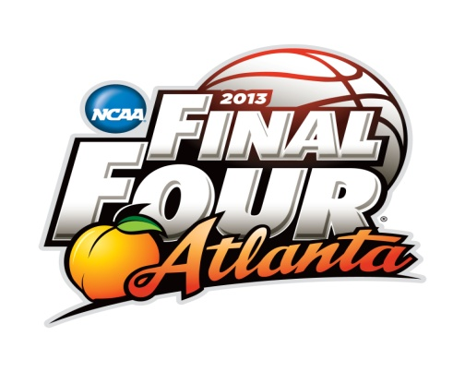
March Madness Infographic Assignment

Create an infographic about 1 of the 64 teams participating in the NCAA basketball Tournament. The infographic does not have to be about basketball it can be about the College and University. Remember the “poster” should be information and graphics.
Using one of the following websites to create your infographic:

Visual.ly Easel.ly

Venngage Piktochart

Your graphic should be visually appealing by incorporating graphics, statistics, and information.

Category | Criteria | Needs Improvement |  |  | → |  |  | Exceeds Expectations |  |  | Points
Creativity | Students use a creativity when making their infographic | 1 | 2 |  |  | 3 | 4 |  |  | 5
Analysis | Students analyze information that is appropriate and interesting. | 1 | 2 |  |  | 3 | 4 |  |  | 5
Visual | The infographic is clear and visually appealing to the audience. | 1 | 2 |  |  | 3 | 4 |  |  | 5
Grammar/Punctuation | Students have no spelling, grammar, or punctuation errors | 1 | 2 |  |  | 3 | 4 |  |  | 5
Work Ethic | Students used class time well and worked diligently on the project. | 1 | 2 |  |  | 3 | 4 |  |  | 5
 |  |  |  |  |  |  |  |  | Total

