Notes about Tables

Insert a Table
- In the Insert tab, under the Tables section, click Table
- Drag your mouse across the grid to select the number of rows and columns for your table (ex. 3x2 would be a 3 column, 2 row table)
OR
- Select Insert Table and enter the number of columns and rows for your table
- Click OK

Add a Table Border
- Under Table Tools, click the Layout tab.
- In the Table group, click Select, and then click Select Table.
- Under Table Tools, click the Design tab.
- In the Table Styles group, click Borders, and then do one of the following:
- Click one of the predefined border sets.
- Click Borders and Shading, click the Borders tab, and then choose the options that you want.

Shading
- Under Table Tools, click the Layout tab.
- In the Table group, click Select, and then click Select Table.
- Under Table Tools, click the Design tab
- In the Table Styles group, click Shading and choose the color of your choice.
- You can also shade individual cells by highlighting that cell that you wish to be shaded.

Merging Cells
- Select the cells that you want to merge by clicking the left edge of a cell and then dragging across the other cells that you want.
- Under Table Tools, on the Layout tab, in the Merge group, click Merge Cells.

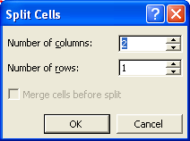
Splitting Cells
- Click in a cell, or select multiple cells that you want to split.
- Under Table Tools, on the Layout tab, in the Merge group, click Split Cells.
- Enter the number of columns or rows that you want to split the selected cells into.

Convert Text to Table

- Insert separator characters — such as commas or tabs — to indicate where you want to divide the text into columns.
- Use paragraph marks to indicate where you want to begin a new row. For example, in a list with two words on a line, insert a comma or a tab after the first word to create a two-column table.
- Select the text that you want to convert.
- On the Insert tab, in the Tables group, click Table, and then click Convert Text to Table.
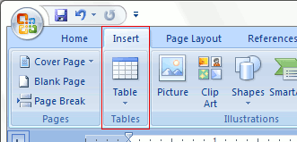
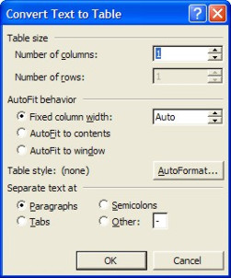
- In the Convert Text to Table dialog box, under Separate text at, click the option for the separator character that is in your text.
- In the Number of columns box, check the number of columns. If you don't see the number of columns that you expect, you may be missing a separator character in one or more lines of text

