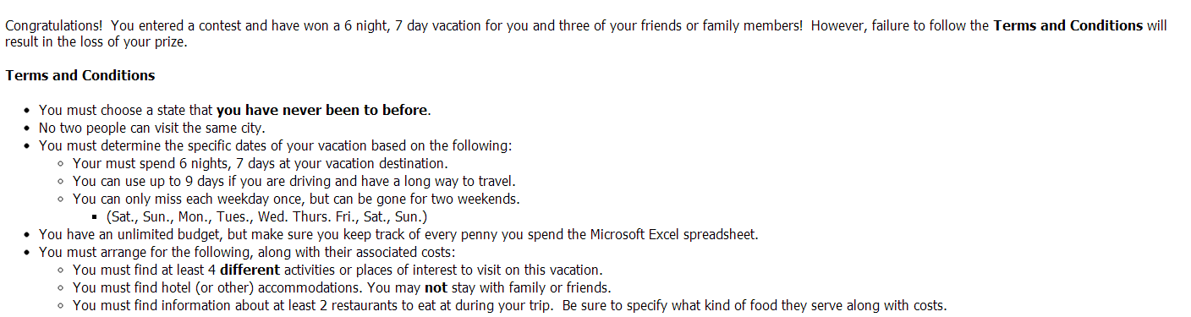
You will need to use the EXCEL worksheet to financially budget and plan your trip.
Create a PowerPoint showing what you did on your vacation.

Below are resources to use to plan your trip.

Remember you cannot travel to the same city as anyone else in the class.

